**Program to print n number from 1 to n.**

**CODE:**

#include <stdio.h>

void

print_n_number (){

int n;

printf (" Enter a number:");

scanf ("%d", &n);

for (int i = 1; i <= n; i++) {

printf (" \t%d\n", i); }}

int

main (){

print_n_number ();

return 0;

}

**OUTPUT:**

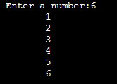

**Program to print table of n numbers.**

**CODE:**

#include <stdio.h>

void

multi_table (){

int n;

printf (" Enter a number:");

scanf ("%d", &n);

for (int i = 1; i <= n; i++)

for (int j = 1; j <= 10; j++) {

printf (" \t%d", i * j);{

printf ("\n\n");} }}

int

main (){

multi_table ();

return 0;}

**OUTPUT:**

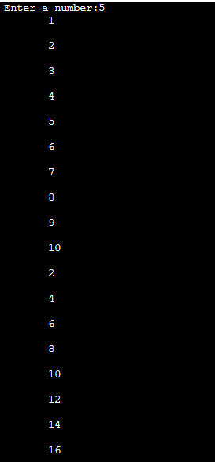

**Program for n rows of triangular matrix**

#include <stdio.h>

void

row_col (){

int n, r;

printf (" Enter number of rows:");

scanf ("%d", &r);

for (int i = 1; i <= r; i++){

for (int j = 1; j <= i; j++){

printf (" %d\t", n);

n++;}

printf (" \n");}}

int

main (){row_col ();

return 0;}



**Program to print n rows with same number.**

#include <stdio.h>

void

row_col (){

int n, r;

printf (" Enter number of rows:");

scanf ("%d", &r);

for (int i = 1; i <= r; i++){

for (int j = 1; j <= i; j++){

printf (" %d\t", i);}

printf (" \n"); }}

int

main (){

row_col ();

return 0;}

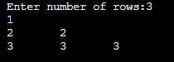

**Program to print previous question with ‘*’.**

#include <stdio.h>

void

row_col (){

int n, r;

printf (" Enter number of rows:");

scanf ("%d", &r);

for (int i = 1; i <= r; i++){

for (int j = 1; j <= i; j++){

printf (" *\t");}

printf (" \n"); }}

intmain (){

row_col ();

return 0;}

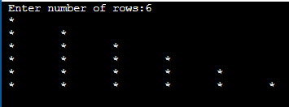

**Program to print previous with alphabets.**

#include <stdio.h>

void

row_col (){

int n, r;

char ch=65;

printf (" Enter number of rows:");

scanf ("%d", &r);

for (int i = 1; i <= r; i++) {

for (int j = 1; j <= i; j++){

printf (" %c\t",ch);

ch++;}

printf (" \n"); }}

int main (){

row_col ();

return 0;

}

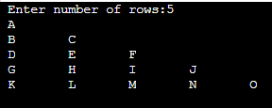

**Program for Fibonacci series**

#include<stdio.h>

int main()

{

int n1=0,n2=1,n3,i,number;

printf("Enter the number of elements:");

scanf("%d",&number);

printf("\n%d %d",n1,n2);//printing 0 and 1

for(i=2;i<number;++i)//loop starts from 2 because 0 and 1 are already printed

{

n3=n1+n2;

printf(" %d",n3);

n1=n2;

n2=n3;

}

return 0;

}

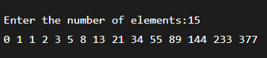

**Program to print value and address of a variable by pointer**

#include <stdio.h>

int main(){

int a = 10;

int *ptr;

ptr = &a;

printf("Value of A = %d\n",a);

printf("Value of A using ptr = %d\n",*ptr);

printf("Address of A using ptr = %d\n",ptr);

return 0;}



**Program to get the actorial of a number**

#include <stdio.h>

long int

factorial (int n{

if (n >= 1){

return n * factorial (n - 1);}

else {

return 1;}}

Int main (){

int n;

printf (" Enter a positive number:");

scanf ("%d", &n);

printf (" Factorial of %d = %ld", n, factorial (n));

return 0;

}



**Program for GCD**

#include <stdio.h>

void gcd(){

int Num1, Num2, i, GCD;

printf("Please Enter two integer Values \n");

scanf("%d %d", &Num1, &Num2);

**for(i = 1; i <= Num1 && i <= Num2; i++){**

**if(Num1 % i == 0 && Num2 % i == 0)**

**GCD = i;**

**}printf("GCD of %d and %d is = %d", Num1, Num2, GCD);}**

int main(){

int Num1, Num2, i, GCD;

gcd();

return 0;}

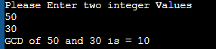

**Program to see math functions**

#include<stdio.h>

#include<math.h>

voidmath () {

double f = -9.33;

int final;

final = floor (f);

printf ("Floor value of %.2f = %d", f, final);

float n, ceilVal;

printf(" Enter any Numeric element : ");

scanf("%f", &n);

ceilVal = ceil(n);

printf("\n The Value of %.2f = %.4f ", n, ceilVal);

double m,output;

printf("Enter a number\n");

scanf("%lf", &m);

output = sqrt(m);

printf("Square root of %.2lf = %f", m,output);}

int main () {

math ();

return 0;

}

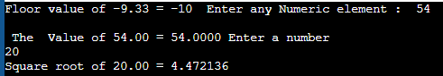

**Program to distance by structure.**

#include<stdio.h>

struct distance

{

float km, m;

} d1, d2, d3;

int

main ()

{

printf (" Enter value of distance in km and m:");

scanf ("%f", &d1.km);

scanf ("%f", &d2.km);

scanf ("%f", &d1.m);

scanf ("%f", &d2.m);

d3.km = d1.km + d2.km;

d3.m = d1.m + d2.m;

printf (" Total distance is \n km %f \n m %f", d3.km, d3.m);

return 0;

}

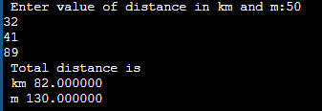

**Program for structure of a book.**

#include<stdio.h>

struct library

{

int id;

char name[20];

char author[20];

float price;

int flag;

} l;

int

main ()

{

int flag;

printf (" Enter book details:");

printf (" \tID: \n\tTitle: \n\tAuthor: \n\tPrice: \n\tFlag:");

scanf (" %s", &l.name);

scanf (" %s", &l.author);

scanf (" %d", &l.id);

scanf (" %f", &l.price);

scanf (" %d", &l.flag);

printf (" Name = %s", l.name);

printf (" Author %s", l.author);

printf (" ID = %d", l.id);

printf (" Price = %f", l.price);

printf (" Flag = %d", l.flag);

if (flag == 1)

{

printf (" Issued");

}

else

{

printf (" Not Issued");

}

return 0;

**}**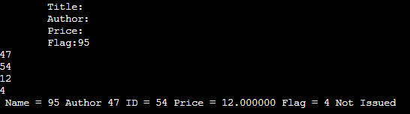

**Program to add to matrices**

#include <stdio.h>

int main()

{

int rowCount, columnCount, i, j;

int firstMatrix[10][10], secondMatrix[10][10], resultMatrix[10][10];

printf("Number of rows of matrices to be added : ");

scanf("%d", &rowCount);

printf("Number of columns matrices to be added : ");

scanf("%d", &columnCount);

printf("Elements of first matrix : \n");

for (i = 0; i < rowCount; i++)

for (j = 0; j < columnCount; j++)

scanf("%d", &firstMatrix[i][j]);

printf("Elements of second matrix : \n");

for (i = 0; i < rowCount; i++)

for (j = 0; j < columnCount; j++)

scanf("%d", &secondMatrix[i][j]);

printf("Sum of entered matrices : \n");

for (i = 0; i < rowCount; i++)

{

for (j = 0; j < columnCount; j++)

{

resultMatrix[i][j] = firstMatrix[i][j] + secondMatrix[i][j];

printf("%d\t",resultMatrix[i][j]);

}

printf("\n");

}

return 0;

}

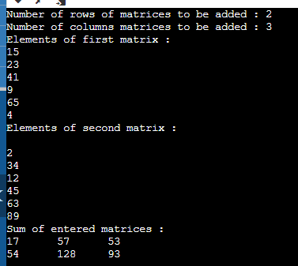

**Sum of an elements of an array**

#include <stdio.h>

int main()

{

int arr[] = {1, 2, 3, 4, 5};

int sum = 0;

int length = sizeof(arr)/sizeof(arr[0]);

for (int i = 0; i < length; i++) {

sum = sum + arr[i];

}

printf("Sum of all the elements of an array: %d", sum);

return 0;

}

